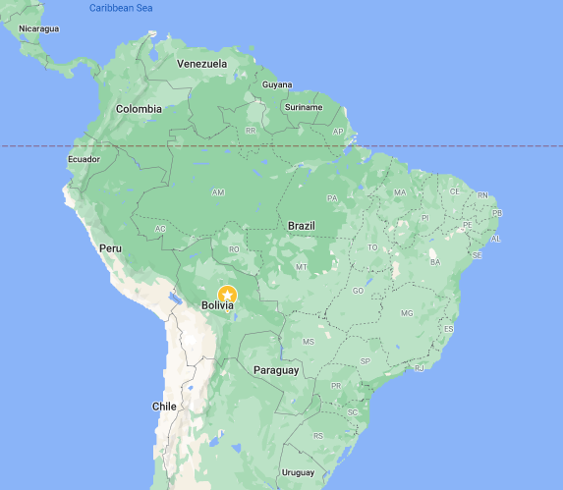

**Project Overview**

Michigan Technological University’s chapter of Engineers Without Borders USA has been working on a road construction project with the community of Santa Barbara, Bolivia. The community of approximately 50 families rely on this road to access the nearby city of Buena Vista. Due to the poor local access to basic supplies, schools, and healthcare, it is important that the community members be able to travel to Buena Vista when necessary. Unfortunately, the connecting road is currently in disrepair. Damage to the road is caused by a long rainy season and a poor maintenance plan. Every year the road washes out in multiple locations, resulting in dangerous driving conditions. EWB-MTU is working to design and construct an economically and environmentally sustainable road that will remain operational and safe throughout the rainy season.

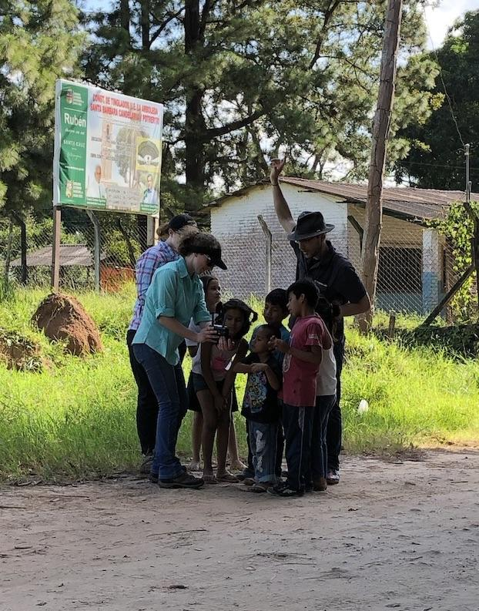

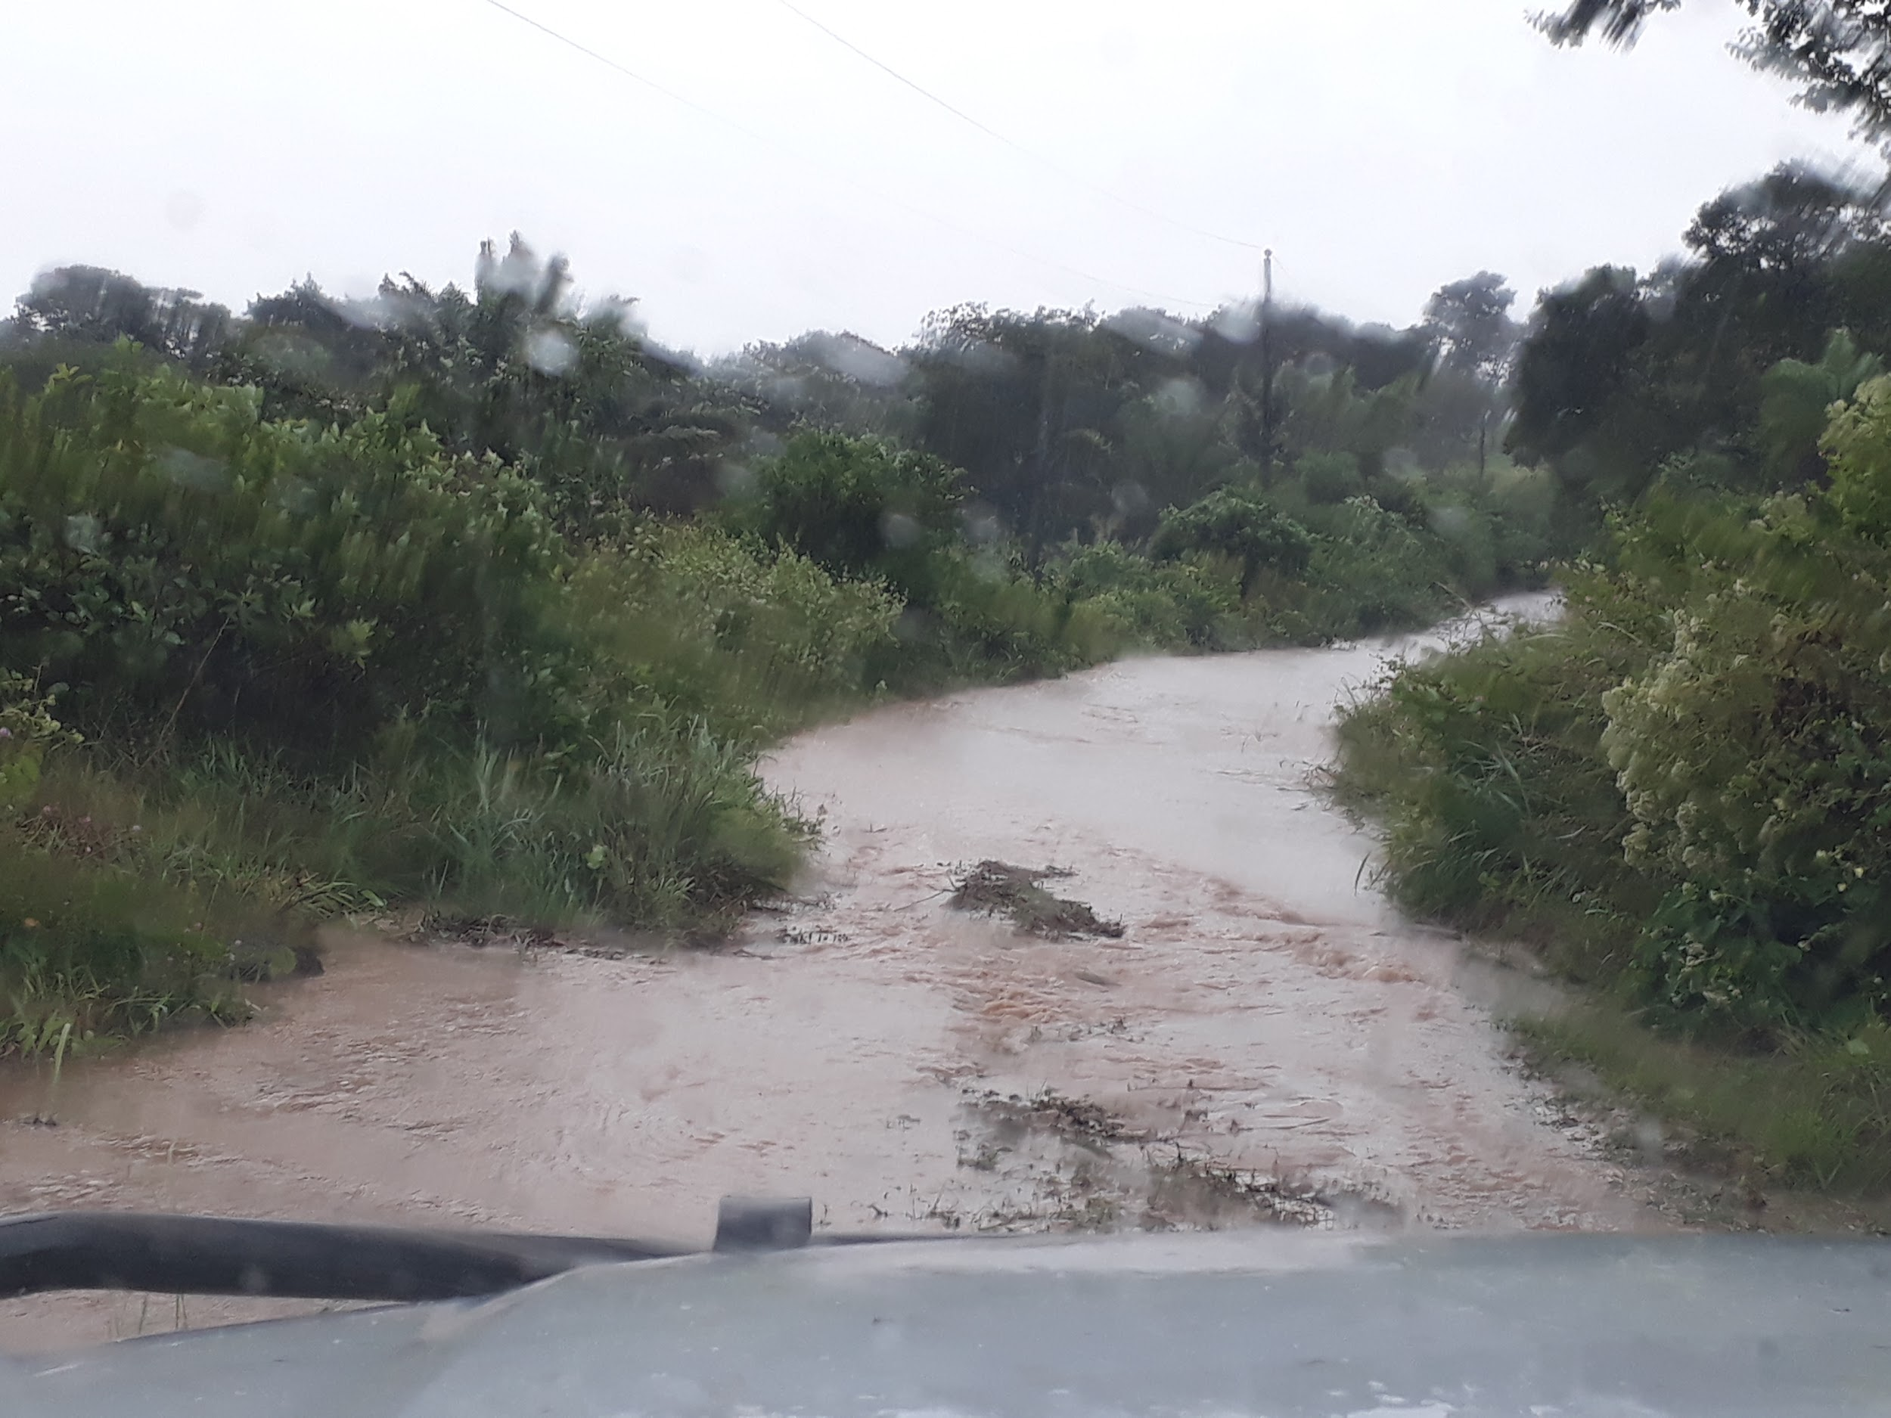Santa Barbara architecture
A group of people sitting in a chair

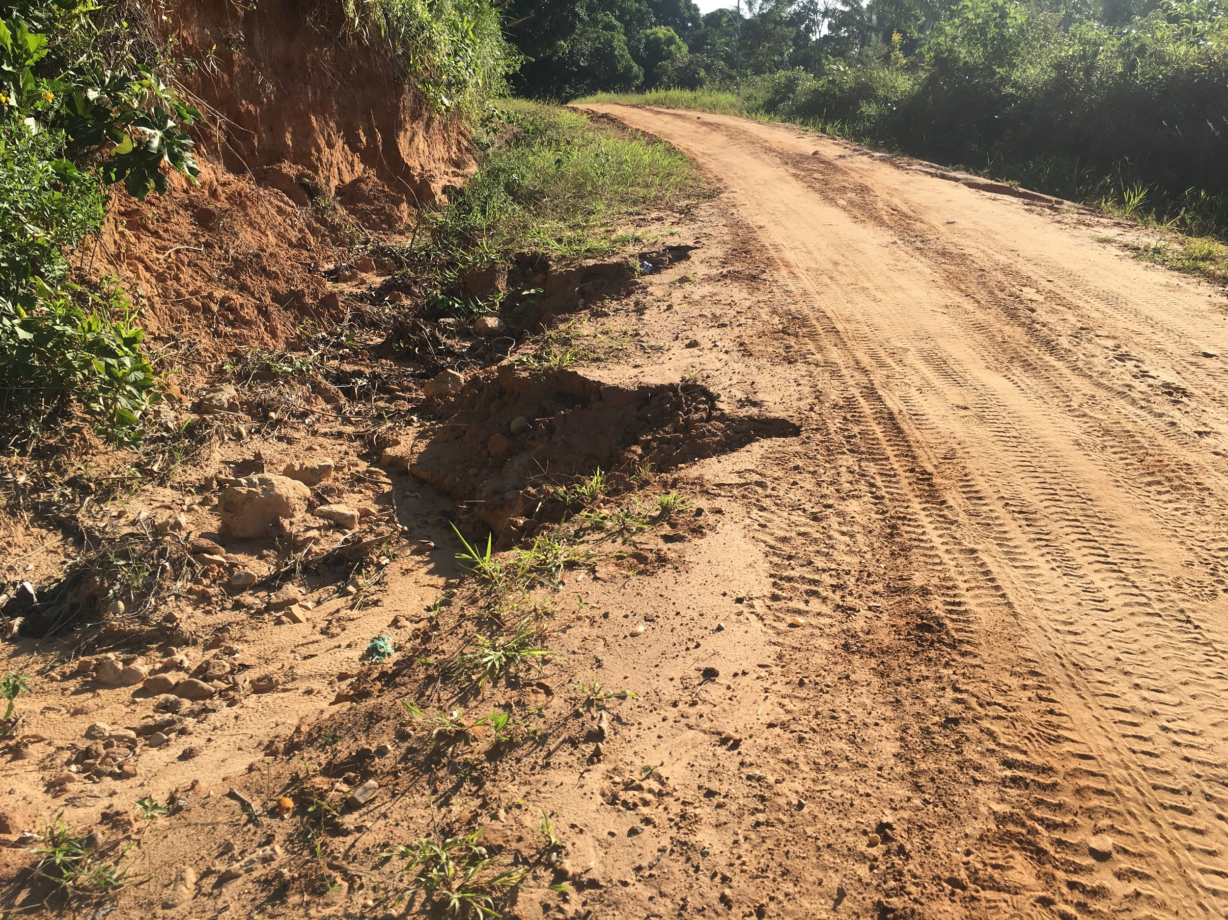

**Future Work**

Rebuilding the entire road in Santa Barbara will take more than one trip to complete. The EWB-MTU team plans to take multiple trips to Bolivia to rebuild the entire road, monitor project performance, and train the community on roadway maintenance. EWB-MTU will continue its relationship with Santa Barbara and continue to help them overcome other infrastructure challenges they may have.

BUILDING A BETTER WORLD | EWB-USA Michigan Technological University

Santa Barbara, Bolivia

Civil Works Project

**Current Work**

EWB-MTU is completing design work, raising funds for project materials, and planning an implementation trip to construct the first new section of road in Santa Barbara. The trip will entail EWB members working with the community to resurface a section of the road with gravel, construct ditches to either side of the road for drainage, and install a culvert so a stream can pass under the road instead of over it. Repairing the section of road will help the people of Santa Barbara access basic services in the nearby town of Buena Vista.

